# UML Exercises

## Class Diagrams

1. Draw a class diagram based on the following case study:

The core requirements of the e-bookstore are to allow its customers to browse and order books, music CDs and computer software through the Internet. The main functionalities of the system are to

* provide information about the titles it carries to help customers make purchasing decisions
* handle customer registration, order processing and shipping
* support management of the system, such as adding, deleting and updating titles, updating customer information, etc.

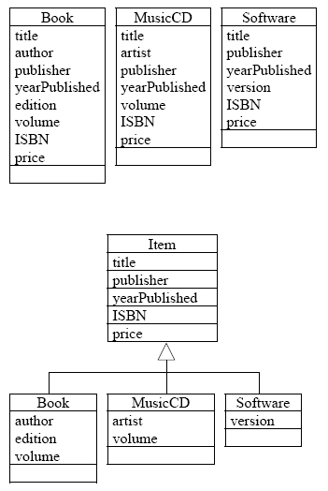

## Sequence Diagrams

1. Draw a sequence diagram based on the following case study:

A user (Account Holder)wishes to use an Automatic Teller Machine (ATM) to make a withdrawal of cash from his/her savings (Bank Account). At the ATM the user inserts his/her card and is requested to enter his/her Personal Identification Number (Pin). Having keyed in his/her Pin, the ATM validates it by checking the user’s details in the Customer class. If the Pin is invalid the user is notified by the ATM and the session ends. A valid Pin will have the ATM prompt the user to select a transaction type. Our scenario is for the user to input a request to do a withdrawal. The ATM will then prompt the user for a withdrawal amount. After the user has keyed in the amount they wish to withdraw, the ATM will instigate a check on the user’s Bank Account to determine if there are sufficient funds to cover the withdrawal amount. If there are insufficient funds the user is notified by the ATM and the session ends. If there are sufficient funds then the system will write details of the transaction to the Transaction class. After the transaction has been recorded the balance in the Bank Account class is updated and then the details of the transaction are passed to the ATM to generate a receipt for the user.

**Answer:**

|  |  |
| --- | --- |
| **Message** | **Message Type** |
| Input Card | Synchronous |
| Request Pin | Return |
| Input Pin | Synchronous |
| Validate Pin | Synchronous |
| Invalid Pin | Return – Alternate Flow |
| Invalid Pin | Return |
| Valid Pin | Return – Alternate Flow |
| Request Transaction Type | Return |
| Input Withdrawal Type | Synchronous |
| Request Withdrawal Amount | Return |
| Input Withdrawal Amount | Synchronous |
| Check Account Balance | Synchronous |
| Insufficient Funds | Return – Alternate Flow |
| Insufficient Funds | Return |
| Sufficient Funds – Record Transaction | Return – Alternate Flow |
| Update Account Balance | Synchronous |
| Transaction Details | Return |
| Transaction Receipt | Return |



1. Draw a sequence diagram based on the following scenario

Via a web page, a teacher is requesting to view some student information. After the teacher has input some student identifying data, the Database Wrapper is passed a request to display the Student Information relevant to the request. To fill the request, the Database Wrapper requires data from the Student Information class and the Student Grades class. Each class is requested to load their respective data. Successful loads lead to the Database Wrapper returning the student information to the Web Interface for displaying to the teacher.

If either of the loads from the Student Information class or the Student Grades class fails then the Database Wrapper notifies the Web Interface to generate and display to the user an error message in a pop up window.



1. Draw a sequence diagram based on the following scenario

The Customer specifies an author on the search page and then presses the search button. The system validates the customer’s search criteria. The system searches the catalog for books associated with the specified author. When the search is complete, the system displays the search results on the Search Results Page. If the customer did not enter the name of an author before pressing the Search button, the system displays an error message to that effect and prompts the customer to re-enter an author name.

**Solution:**

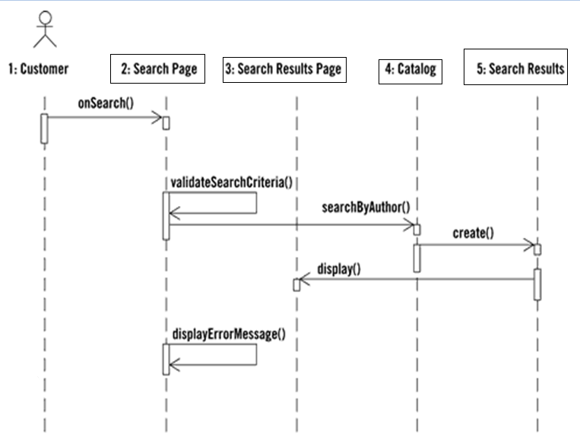

1. Draw a sequence diagram based on the following scenario

The scenario begins when the player chooses to start a new round in the UI. The UI asks whether any new players want to join the round; if so, the new players are added using the UI. All players' hands are emptied into the deck, which is then shuffled. The player left of the dealer supplies an ante bet of the proper amount. Next each player is dealt a hand of two cards from the deck in a round-robin fashion; one card to each player, then the second card. If the player left of the dealer doesn't have enough money to ante, he/she is removed from the game, and the next player supplies the ante. If that player also cannot afford the ante, this cycle continues until such a player is found or all players are removed.

1. Draw a sequence diagram based on the following scenario

The scenario begins when the user chooses to add a new appointment in the UI. The UI notices which part of the calendar is active and pops up an Add Appointment window for that date and time. The user enters the necessary information about the appointment's name, location, start and end times. The UI will prevent the user from entering an appointment that has invalid information, such as an empty name or negative duration. The calendar records the new appointment in the user's list of appointments. Any reminder selected by the user is added to the list of reminders.

If the user already has an appointment at that time, the user is shown a warning message and asked to choose an available time or replace the previous appointment. If the user enters an appointment with the same name and duration as an existing group meeting, the calendar asks the user whether he/she intended to join that group meeting instead. If so, the user is added to that group meeting's list of participants.

## State Transition Diagram

1. Draw a state transition diagram for the hotel reservation scenario:

When a customer requests for a room, the operator checks the availability of rooms first. If a room is available, the booking is confirmed and the number of available rooms is decremented. Once a customer uses a room, the details are archived after final payment is effected.

If no rooms are available, the customer is placed on a waiting list. A customer can cancel a booking if he/she is on the waiting list or even cancel a confirmed booking.

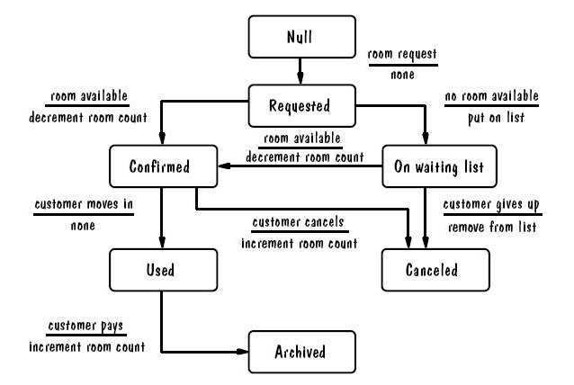

1. Draw the state transition diagram for a chess game

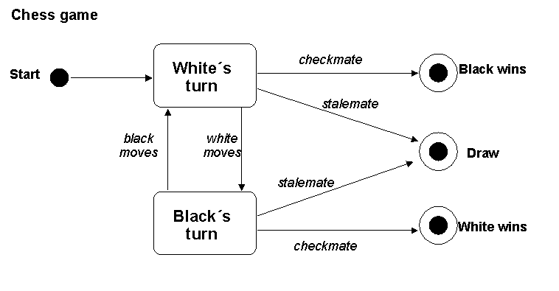

1. Draw a state Transition diagram based on the following case study:

A user (Account Holder)wishes to use an Automatic Teller Machine (ATM) to make a withdrawal of cash from his/her savings (Bank Account). At the ATM the user inserts his/her card and is requested to enter his/her Personal Identification Number (Pin). Having keyed in his/her Pin, the ATM validates it by checking the user’s details in the Customer class. If the Pin is invalid the user is notified by the ATM and the session ends. A valid Pin will have the ATM prompt the user to select a transaction type. Our scenario is for the user to input a request to do a withdrawal. The ATM will then prompt the user for a withdrawal amount. After the user has keyed in the amount they wish to withdraw, the ATM will instigate a check on the user’s Bank Account to determine if there are sufficient funds to cover the withdrawal amount. If there are insufficient funds the user is notified by the ATM and the session ends. If there are sufficient funds then the system will write details of the transaction to the Transaction class. After the transaction has been recorded the balance in the Bank Account class is updated and then the details of the transaction are passed to the ATM to generate a receipt for the user.

[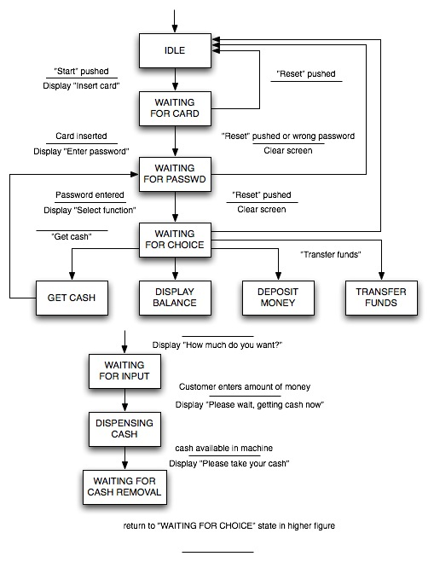](http://yourdon.com/strucanalysis/wiki/index.php?title=Image:Figure136b.jpg)